**Algorithm:**

**HOG (Histogram Oriented Gradients):**

The most popular way for face and object detection, in general, is using **HOG classifiers**. **HOG stands for Histogram of Oriented Gradients**. The crux of the matter is in finding appropriate feature descriptors for an image, be it faces or other objects. The Histogram of Oriented Gradients (HOG) is a function descriptor used primarily for object recognition in image processing. A function descriptor is a representation of an image or an image patch that by extracting valuable information from it, simplifies the image.

The theory behind the descriptor histogram of directed gradients is that the distribution of intensity gradients or edge directions will define the appearance and shape of local objects within an image. The x and y derivatives of an image (Gradients) are helpful because due to sudden change in amplitude, **the magnitude of gradients is high around edges and corners** and we know that edges and corners pack a lot more object shape details than flat regions. Therefore, the gradient path histograms are used as properties of this descriptor.

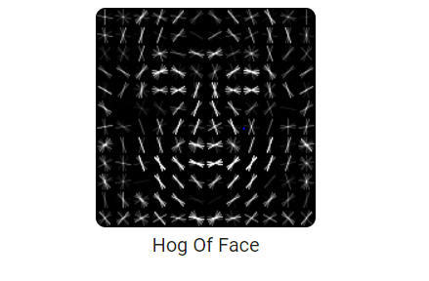

**Steps to calculate HOG descriptors for face detection:**

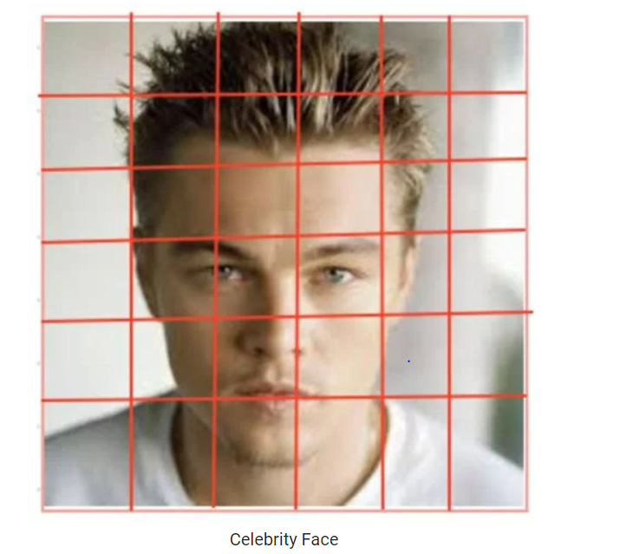

1. The picture is divided into 8 to 8 cell blocks, and for each 8 to 8 cell block, a histogram of gradients is measured.
2. A vector of 9 buckets (numbers) corresponding to angles from 0 to 180 degrees is basically a histogram (20-degree increments).
3. The values of these 64 cells (8X8) are binned into these 9 buckets and cumulatively inserted.
4. This restricts 64 values to 9 values, in principle.

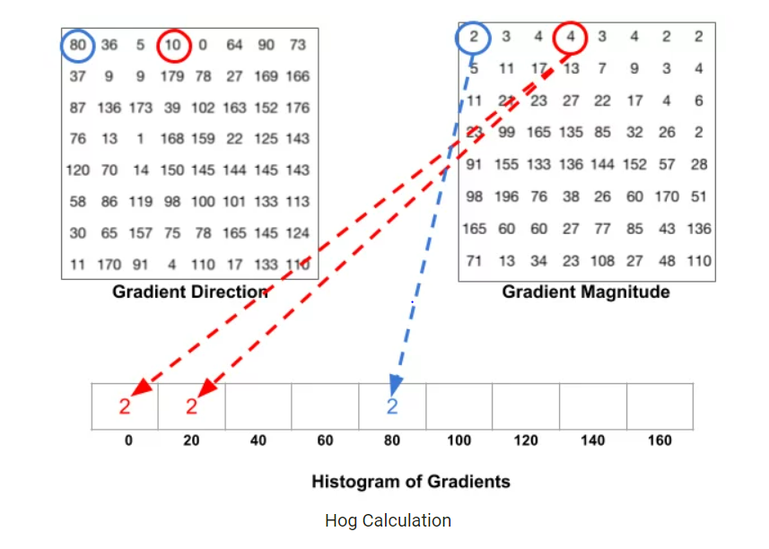

ExpectedFace Detection Results:



**Expected Results:**

